***Detailed Report about Sales for Gus Segura Company***

# Executive summary

**We exported the sales data from our data base and we conduct some analysis on it to gain insights into some of our sales operations and study ways to enhancing our services based on a certain scope.**

## Scope

## 

* ***Customer Loyalty***
* ***Strength and weakness***

## Data specific

***Here are data we used to conduct our analysis.***

* ***Sales***
* ***QTR_ID***
* ***MONTH_ID***
* ***YEAR_ID***
* ***Country***
* ***City***
* ***Product line***
* ***Customer Name***

# The analysis

## Strength and weakness

* ***What is the most product line of sales?***

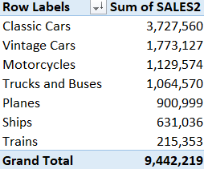

***Based on table above we found that classic cars is the most product line of sales.***

***Recommendation:***

* ***We must that focus on production of classic cars because it most of sales.***
* ***We must that put on it more promotions in order to continue to achieve high sales.***
* ***We must that also put on it discount that will it brings more our sales.***

## According to Strength and weakness

* ***What is year of the most of sales?***

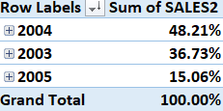

***Based on table above we found that 2004 is the most year of sales by 48.21% of grand total.***

***Recommendation:***

* ***We found that classic cars in this year was sold with high amount and it cause the most of sales in this year so should increase production of it.***
* ***It will happen if we increase ways to sold it through markets and company and export it more countries.***
* ***It will happen also if we marketing it through all social media platforms.***

## According to Strength and weakness

* ***What is the most quarter achieve of sales?***

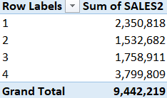

***Based on the table above we found that fourth quarter is the most achieve sales.***

***Recommendation:***

* ***We found that November is the most month of achieve sales cause it used to ways of***

***Effective marketing.***

* ***We must apply the same marketing methods to the rest of the months in order to increase its sales.***

## According to Strength and weakness

* ***What is the most country of sales?***

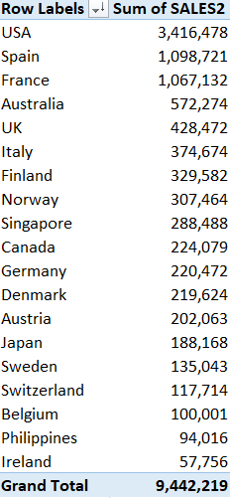

***Based on the table above that the top 3 of country of sales (USA-Spain-France).***

***Recommendation:***

* ***We found that the 3 of countries (USA-Spain-France) achieve most of sales because of that it put more promotions on products as (discount-gifts).***
* ***Unlike Ireland, the Philippines and Belgium, which use high prices without any promotion or benefits for customers.***
* ***We must that apply the same promotions who we apply in the top 3 countries of sales.***

## According to Strength and weakness

* ***What is the most city of sales?***

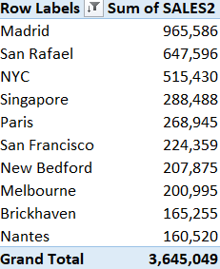

***Based on the table above we found that Madrid is the most city of sales.***

***Recommendation:***

* ***We must that used to same ways of marketing of sales as Madrid on all cities in order to achieve more of sales.***
* ***We must that improve our material in (Nantes-Brickhaven-Melbourne) in order to achieve more of sales.***
* ***And we must increase our product line also in order to achieve more of sales.***

## Customer Loyalty

* ***What is the top customer of sales?***

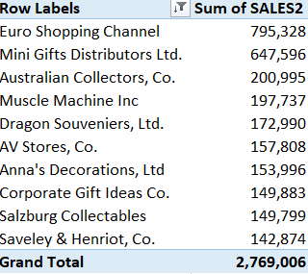

***Based on the table above we found (Euro shopping channel-Mini gifts Distributors ltd) is the top customer of sales.***

***Recommendation:***

* ***We must offer to our customer more promotions and benefits in order to gain their loyalty that will to increase our sales.***
* ***We must offer also to our customers who achieve little of sales some offers as discount and gifts in order to increase of our sales.***